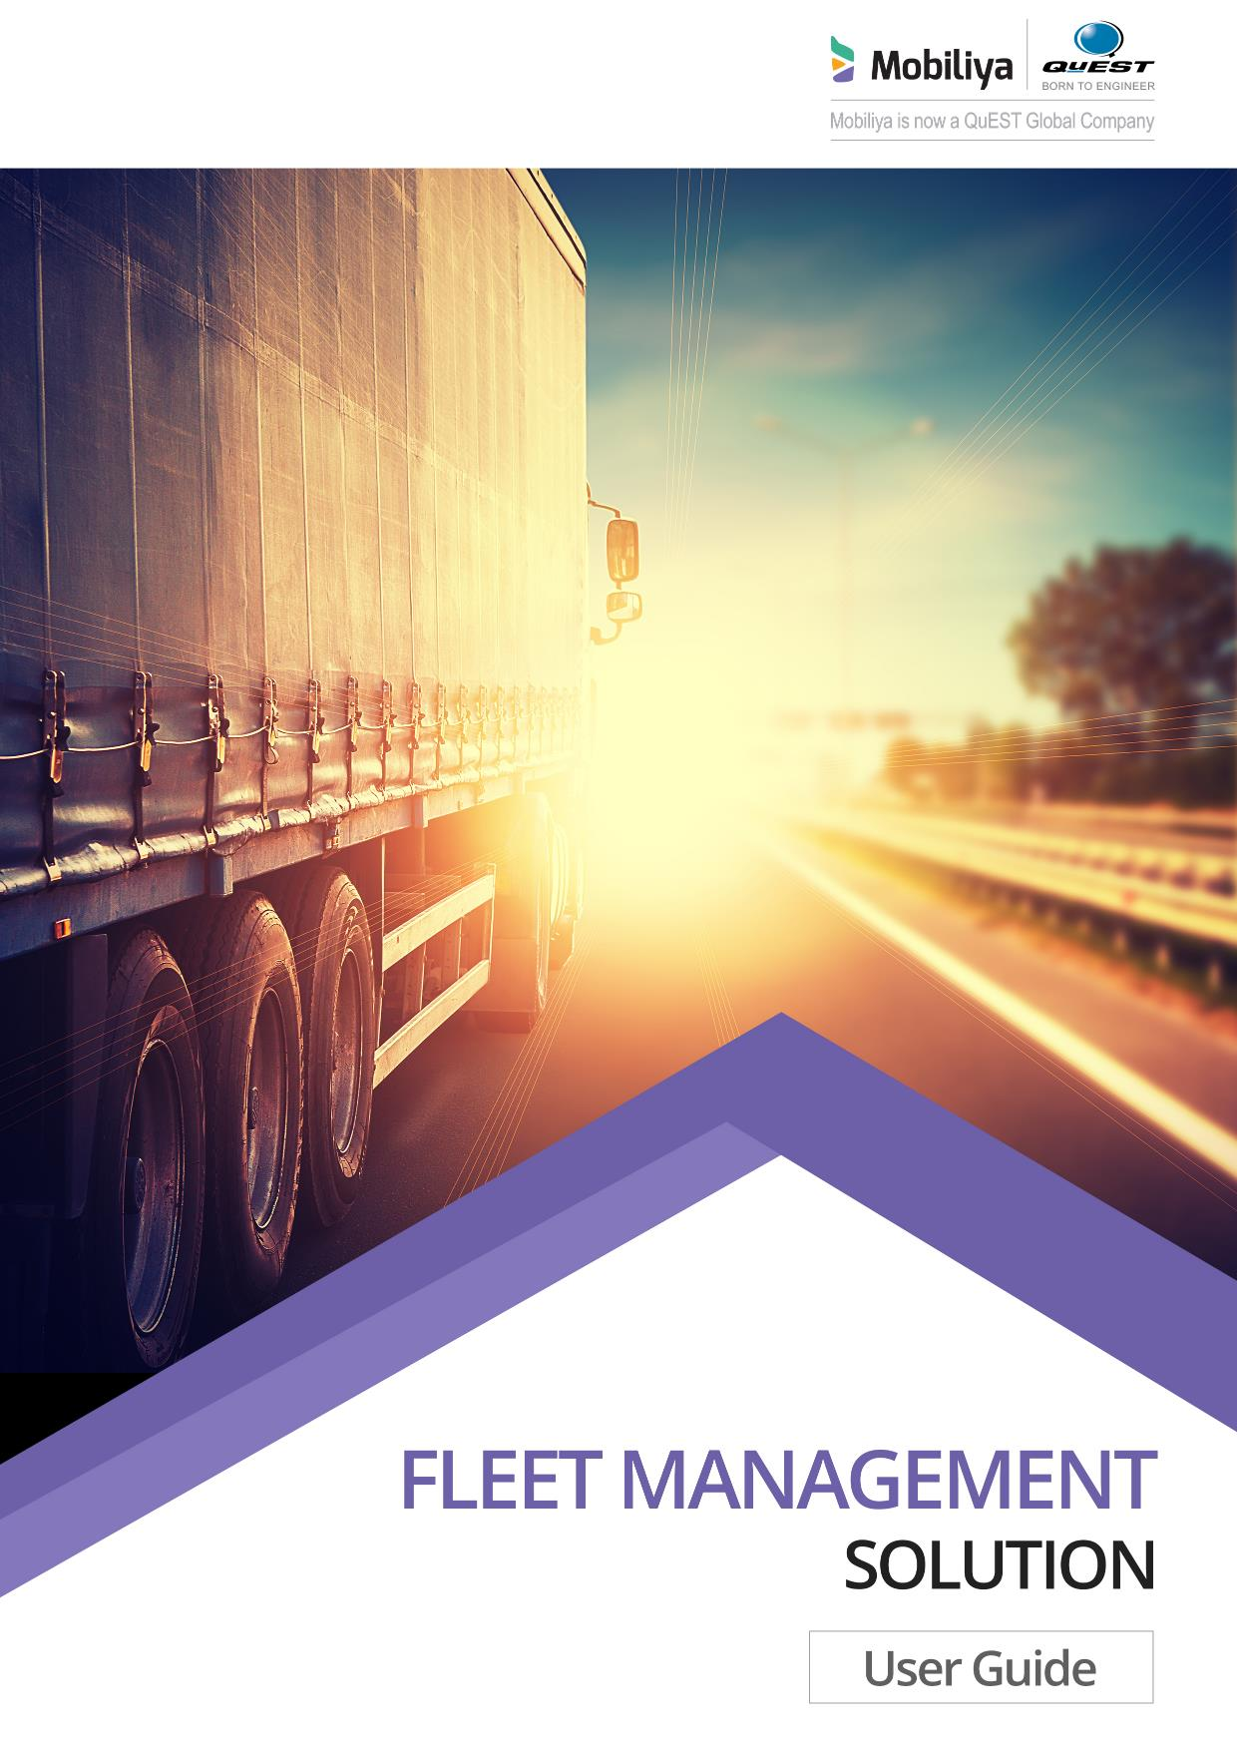

|  |  |
| --- | --- |
| **Revision History** | |
| Version No. | 1.0 |
| Authorized By | Sagar Shah |

© 2018 Mobiliya Technologies

Strictly Private and Confidential. No part of this document should be reproduced or distributed without the prior permission of Mobiliya Technologies.

Contents

[1. Introduction 5](#_Toc521946192)

[1.1. About this Guide 5](#_Toc521946193)

[1.2. About Mobiliya Fleet Management Solution 5](#_Toc521946194)

[2. Intended Audience 5](#_Toc521946195)

[3. Web Portal 6](#_Toc521946196)

[3.1. Prerequisites 6](#_Toc521946197)

[3.2. Tenant Login 6](#_Toc521946198)

[3.2.1. Login 6](#_Toc521946199)

[3.2.2. User Management 7](#_Toc521946200)

[3.2.3. Fleet Management 8](#_Toc521946201)

[3.2.4. Vehicle Management 8](#_Toc521946202)

[3.2.5. Device Management 8](#_Toc521946203)

[3.2.6. Reports 8](#_Toc521946204)

[3.2.7. Rules Management 8](#_Toc521946205)

[4. Mobiliya Fleet - Android Application 9](#_Toc521946206)

[4.1. Pre-requisites 9](#_Toc521946207)

[4.2. Compiled Application 9](#_Toc521946208)

[4.3. Server Configuration Changes 9](#_Toc521946209)

[4.4. Application Usage 11](#_Toc521946217)

[4.4.1. Driver Sign In 11](#_Toc521946218)

[4.4.2. Forgot Password 11](#_Toc521946219)

[4.4.3. Connect Dongle 12](#_Toc521946220)

[4.4.4. Location 12](#_Toc521946221)

[4.4.5. Dashboard 13](#_Toc521946222)

[4.4.6. Ongoing trip 13](#_Toc521946223)

[4.4.7. Trip Details 14](#_Toc521946224)

[4.4.8. Trip List 14](#_Toc521946225)

[4.4.9. Vehicle Health 15](#_Toc521946226)

[4.4.10 Settings 15](#_Toc521946227)

[4.4.11 User Information 16](#_Toc521946228)

[4.4.12 Vehicle Information 16](#_Toc521946229)

[4.4.13 App Settings 17](#_Toc521946230)

[4.4.14 App Settings Help 18](#_Toc521946231)

[4.4.15 About Us 18](#_Toc521946232)

# Introduction

## About this Guide

The purpose of this user guide is to assist end users in understanding the Mobiliya Fleet Management solution. It is a step-by-step walkthrough of the usage guidelines of the solution.

## About Mobiliya Fleet Management Solution

The Fleet Management solution consists of following components:

* Vehicle (Truck/Car)
* OBD/J1939 Dongle
* Mobile Application
* Azure Cloud Application

The solution supports commercial vehicles and cars supporting J1939 and OBD protocols respectively.

A user can connect a Dongle to a vehicle which can retrieve vehicle diagnostic information and forward this information to a mobile application over Bluetooth. The mobile application will further forward this information to the cloud. The cloud application then performs detailed analysis of a given data and provides different reports to different stakeholders/users.

There are 3 types of users actively involved in this system.

* Tenant Admin
* Fleet Admin
* Driver

# Intended Audience

This guide is intended for the users who want to use the system. The guide explains different flows for following user roles:

1. Tenant Admin

* By default, a Tenant Admin user is created in the system.
* Tenant Admin can manage users, fleets, vehicles and view reports.

1. Fleet Admin

* Fleet Admin is added by the tenant.
* Fleet Admin can add, update or delete drivers.
* Fleet Admin can also remove vehicles from own fleet.

1. Driver

* Drivers can only login to the Android app and are not allowed to login on the web portal.
* Drivers can take trips, view vehicle health.
* Drivers can view their driving behavior.

# Web Portal

Launch the application URL received as part of web portal deployment in a browser. It should open the login page.

## Prerequisites

* Only tenant admins & fleet admins registered in the system can login into the web portal.
* There is only one tenant admin pre-configured in the system. Tenant admins can add fleet admins.

## Tenant Login

The default login credentials for a tenant are pre-configured in the web portal as mentioned below:

**Tenant Admin:**

* Username: [tenantadmin@mobiliya.com](mailto:tenantadmin@mobiliya.com)
* Password: welcome

To change the login username, connect to the SQL database deployed on Azure. Change the ‘EMAIL’ field under ‘users’ table.

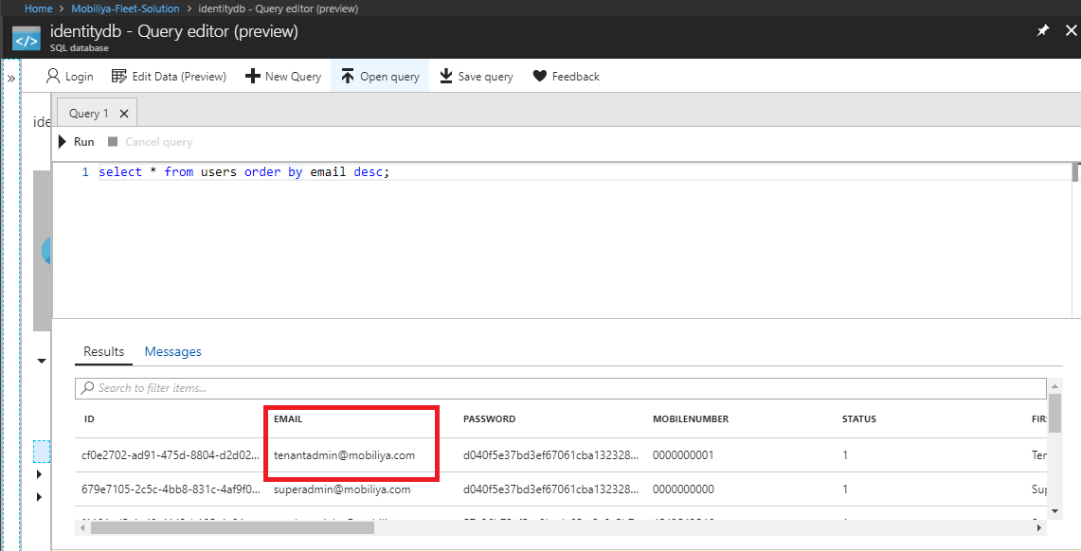

To change the login password, follow the ‘Forgot Password’ flow on the web portal login page.

To start using the system as a Tenant Admin, follow the steps given below:

## Login

Enter username and password and click on Sign In button. In case a user does not remember the password, user can click on **‘Forgot Password’** link to reset password.

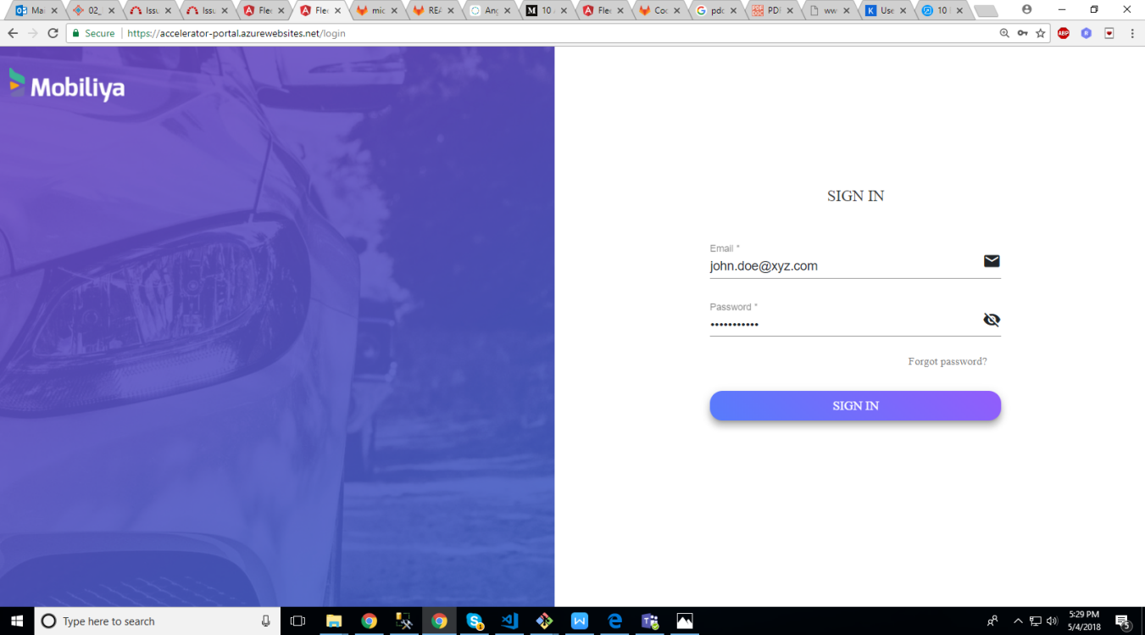

## User Management

On logging in, tenant admin is directed to the **Dashboard**. Tenant admin can then add fleet admin/driver. Navigate to ‘Users’ tab and click on **Add** button to add user.

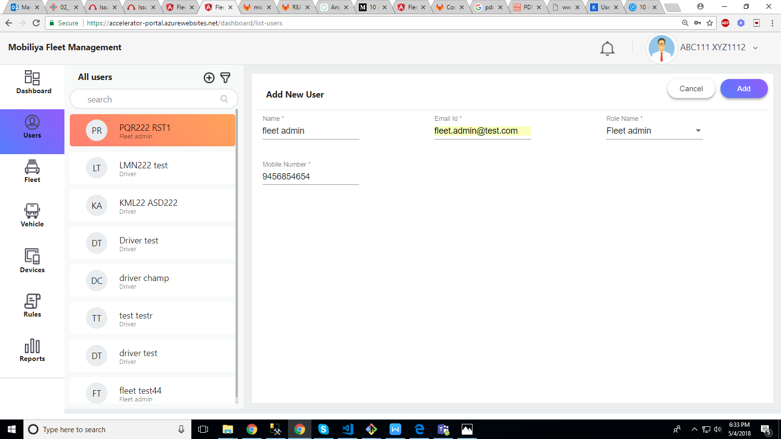Once tenant Admin adds a user, the newly added user will receive an email containing a link to set new password.

When the user opens that link, it will prompt to set a new password as shown below:

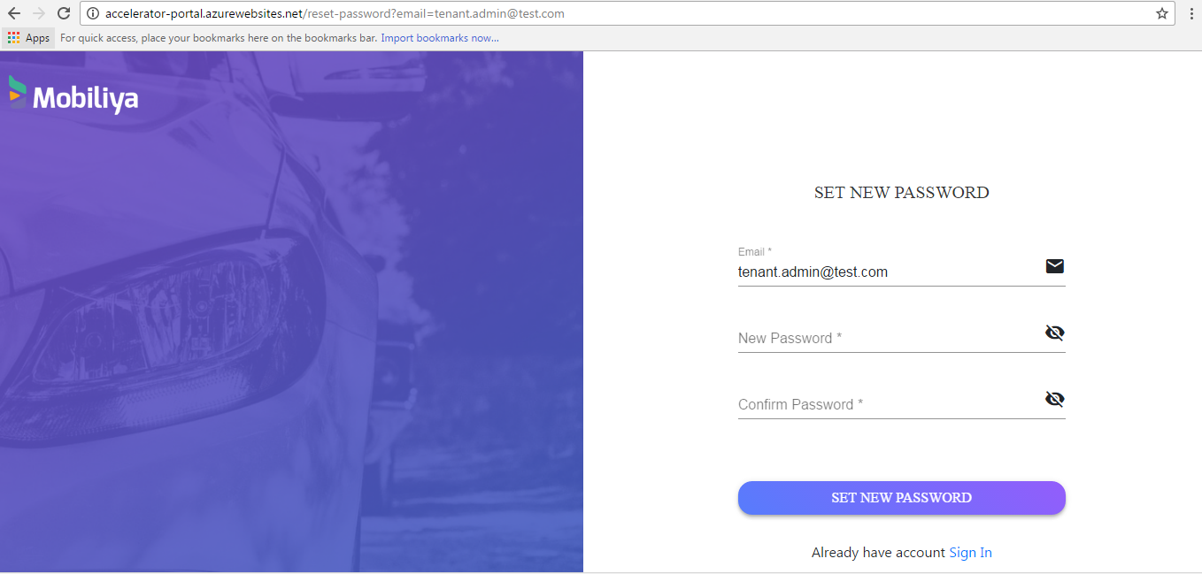

## Fleet Management

Tenant admin can add, edit or delete fleets. Vehicles/drivers can be assigned to fleets.

## Vehicle Management

Tenant admin can add, edit or delete vehicles. This section also contains trip information of vehicles.

## Device Management

Tenant admin can add, edit or delete devices. Devices are nothing but dongles which are associated with the respective vehicles.

## Reports

Tenant admin can view reports. Reports are generated in **PowerBI**. Reports are based on vehicle that is selected. Reports include maximum of one-week data where date can be selected.

## Rules Management

Tenant admin can create speeding or Geo-fencing rules and assign it to drivers within a fleet. Notifications will be shown on the portal when the rules are crossed.

# Mobiliya Fleet - Android Application

## Pre-requisites

* Device support - Android 6.0 Marshmallow and above.
* Android application is tested on OBD-II and J1939 (BlueFire LE simulator) dongles supporting Bluetooth. Please find below the reference link for each dongles,

OBD-II: <https://www.amazon.com/BAFX-Products-Bluetooth-Diagnostic-Scanner/dp/B005NLQAHS>

J1939: <https://bluefire-llc.com/store/500k-j1939j1708-ios-adapter>

* Driver who is using the application is already registered on the web portal and assigned a vehicle and dongle.

## Compiled Application

A compiled application can be downloaded from the link given below:

<https://agreeyamobilitynet-my.sharepoint.com/:u:/g/personal/kunal_shinde_mobiliya_com/EQ5ViozF2X5HpzSYEbA1OLMBjzMJs9SuXjpJZZV5cmO24A?e=B5ydBh>

APK Version: 1.0.51

## Server Configuration Changes

**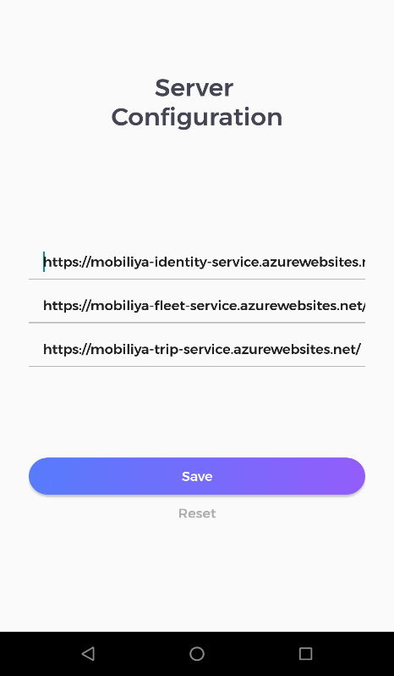**To set the server URLs follow the steps listed below in the Android application:

* Launch the app after installation.
* On Login Page -> Settings Icon (Right Top corner) -> Settings Page.
* Reset the old URLs using the reset button.
* Copy paste the new URLs as per your deployment.
* Steps to get required URLs are mentioned subsequently.

For identity, fleet and trip services’ URLs:

* To get URLs of respective services, on Azure portal, go to **Resource Groups** -> <Resource group name> ->app service overview (the image given below is for fleet service)

*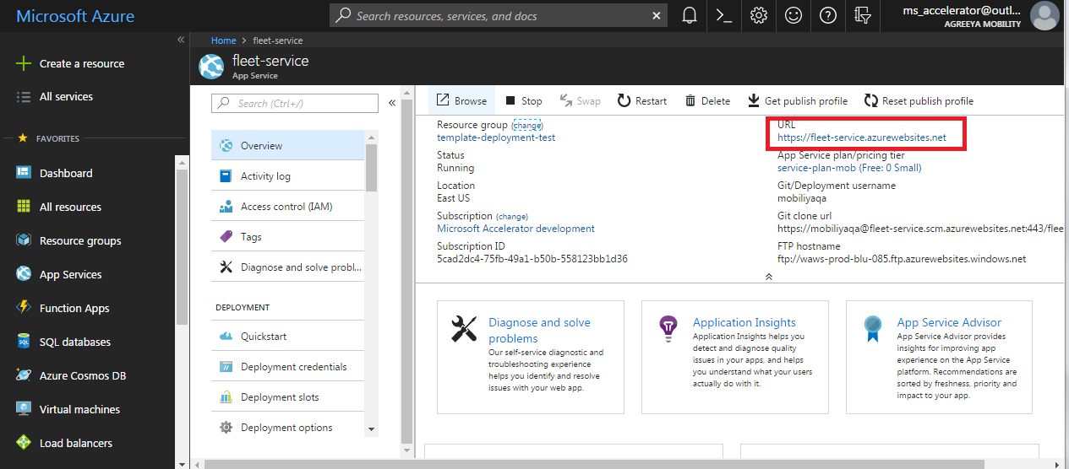*



## Application UsageC:\Users\sagar\Desktop\login.png

## Driver Sign In

* Driver can Sign In from here. Driver can change a password using Forgot Password option.
* The company name/vehicle number (if assigned) would be specified in the welcome email received as part of driver registration by the fleet owner.
* On successful login, the location of the driver will be queried and proceeded to the dongle connection screen.
* Driver can alternatively skip dongle connection and proceed to Dashboard or connect to an OBD II/J1939 dongle connected in the car and proceed to Dashboard on successful pairing.

**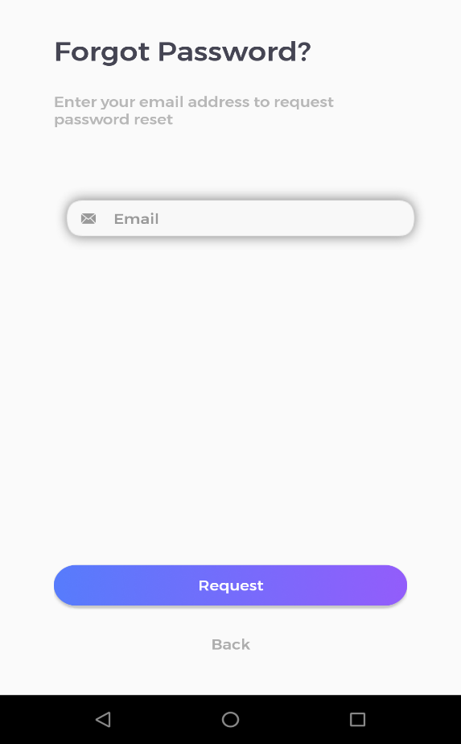**

## Forgot Password

The Forgot Password option can be accessed from the Sign-In Screen. Driver can reset password from here in case user cannot recall the existing password.

The driver will receive an email with the provision to set new password.

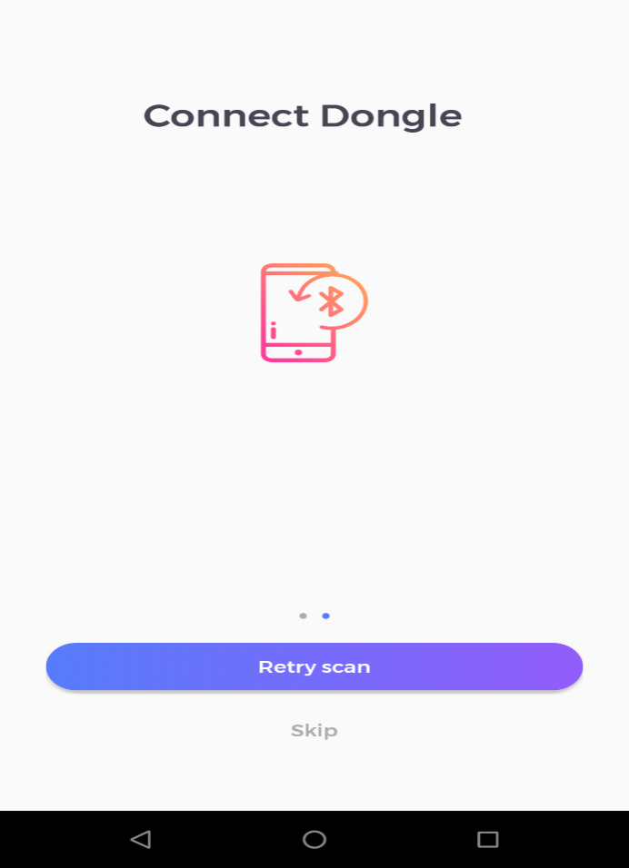

## Connect Dongle

On login driver has to pair with adapter which is connected to vehicle he is driving .He can skip this if there is no adapter.

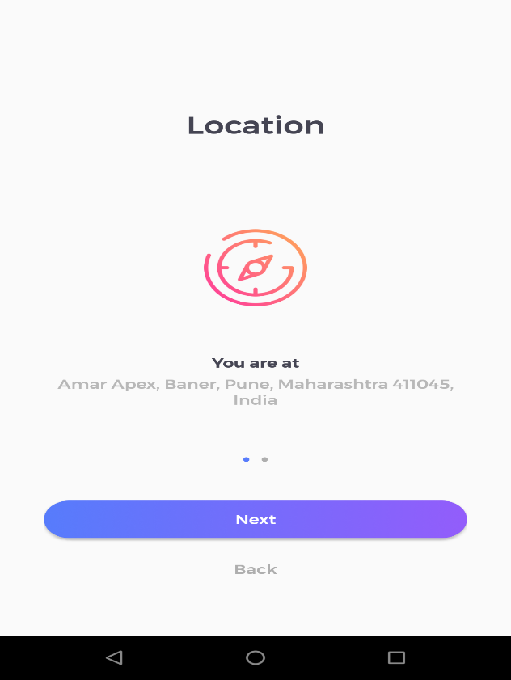

## Location

Location page takes location permission required for the app from user, and shows current location of user.

## Screenshot_20180502-174014Dashboard

After successfully logging in and connecting with the dongle, driver is redirected to the dashboard where he can manage trips and view own ratings and overall vehicle health.

## C:\Users\user\Desktop\03-july-18\03-july-18\onGoingTrip.pngOngoing trip

Driver can start trips from the Dashboard “START TRIP” button. He will be able to see running trip on this screen. Driver can see his current and start location on map also can view trip related parameters like “miles driven”, “Trip time”, ”Fuel used” and so on. These parameters keep updating till the trip ends. Once trip is stopped these values obtained from trip is synced with server.

Below are the parameters and there representations

* **Miles Driven**- Shows miles driven from start to current location of vehicle.
* **Trip Time**- Notifies time of trip from start to current location.
* **Fuel** used- Shows fuel used till current location. It can be obtained when vehicle is connected with adapter.
* **Stops**- Represents number of pauses trip has taken.
* **Hard Braking**-Number of time vehicle is harshly driven
* **Speeding**- Represents number of time vehicle is at 100 or more speed.

**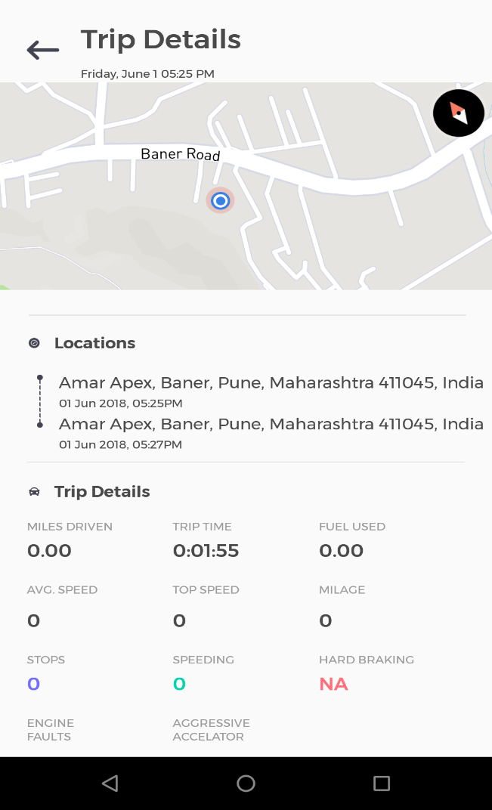**

## Trip Details

Driver can start trips from the application. Once completed, driver can view the trip details with driving behavior. Driver can view trip history later.

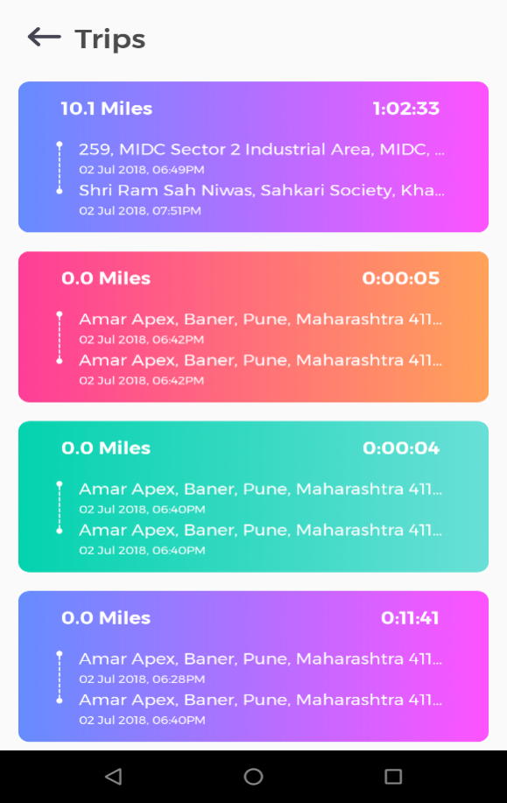

## Trip List

Driver can view latest 10 trips taken by registered vehicle. On selecting of single trip from list he can view all the details of that trip in “Trip details page”.

**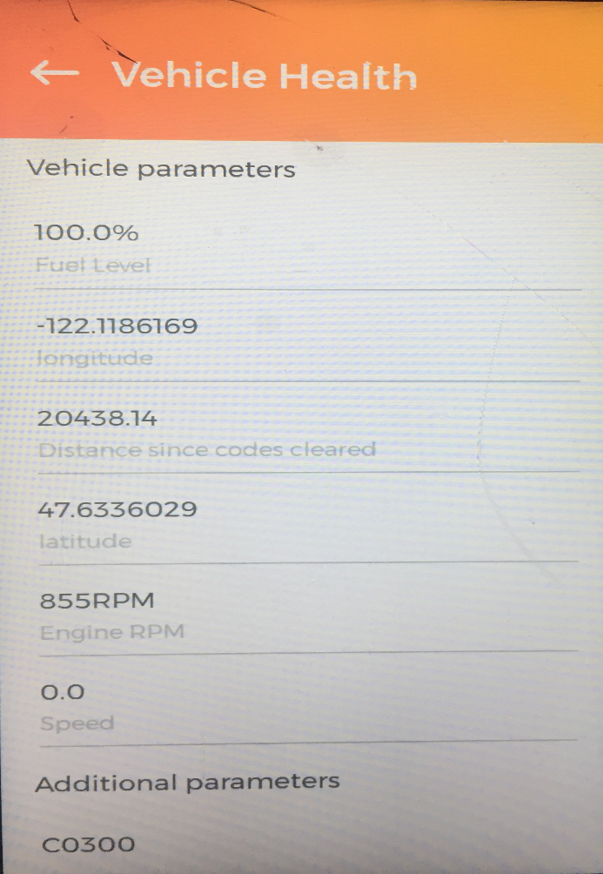**

## Vehicle Health

Driver can view all adapter parameters of the vehicle on this page. If vehicle is not connected to adapter its current Latitude, Longitude will be shown.

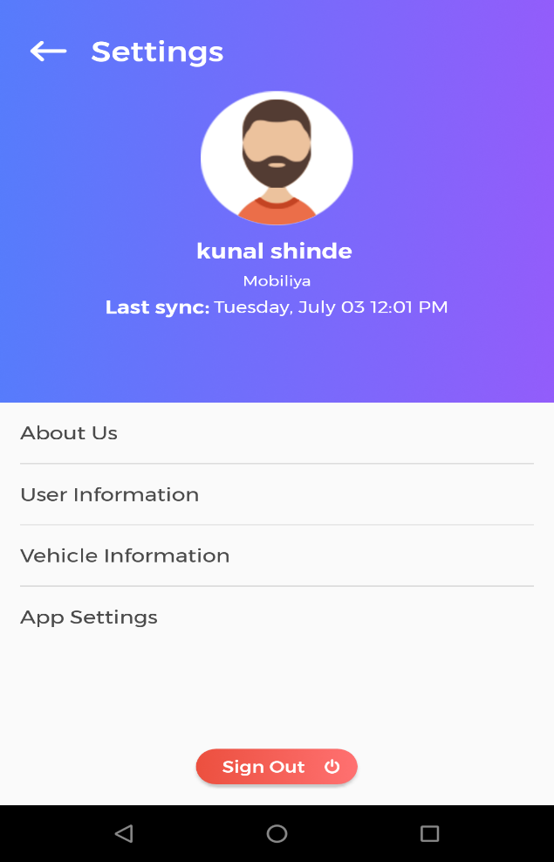

## Settings

Driver can view Last synced time and date .He can logout of application, view user and vehicle information, and can edit configuration settings through app settings page.

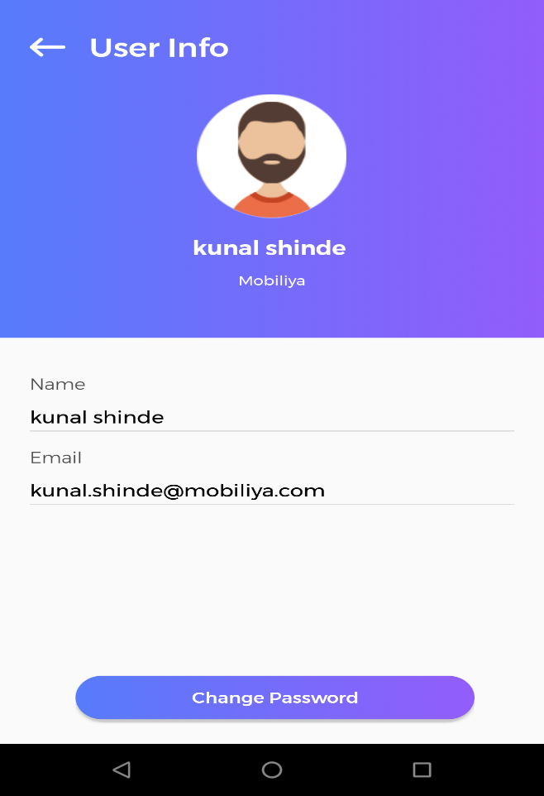

## User Information

Driver can view logged in user information and can update password through change password page.

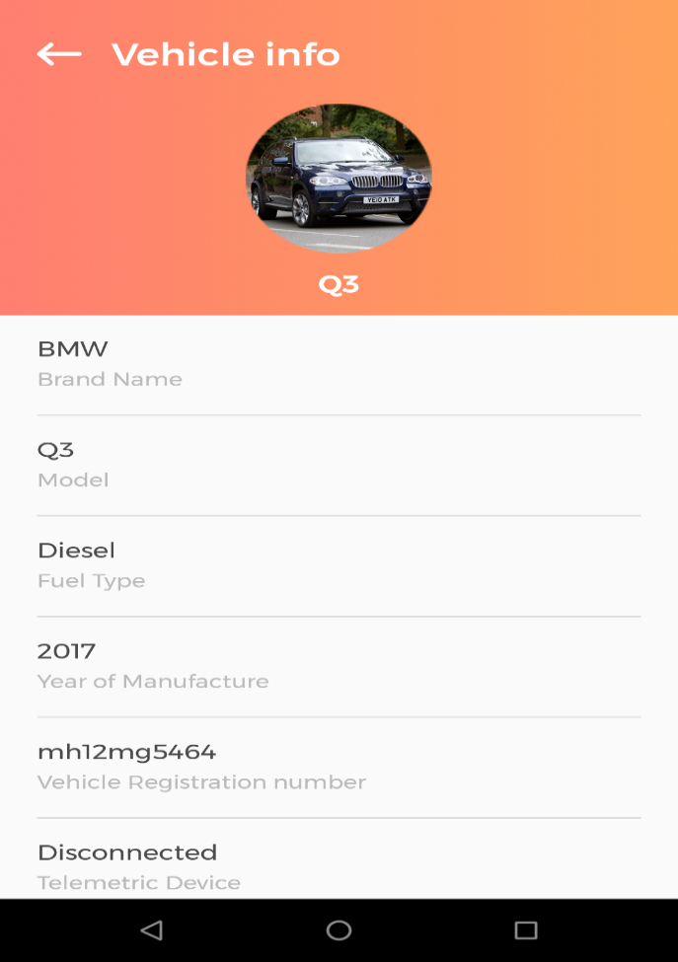

## Vehicle Information

Driver can view logged in vehicle information on this page.

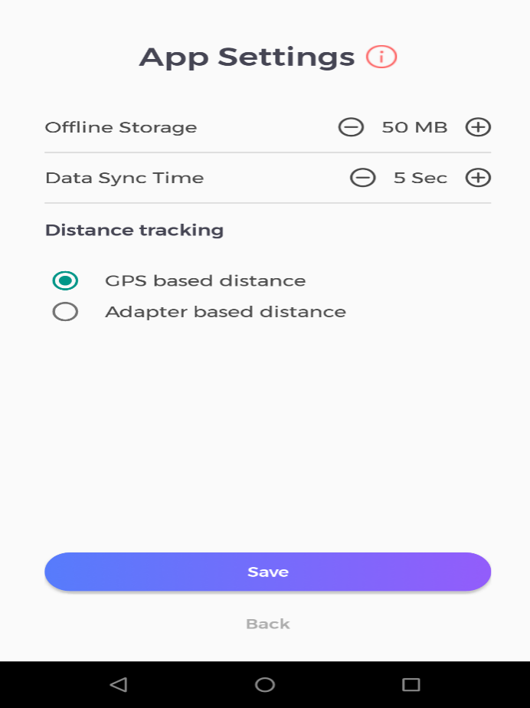

## App Settings

In App Settings page driver can configure

* **Offline storage** - Shows Offline storage memory limit of app, when app is running with no network connectivity for longer time the data will be stored in local database till the given limit. If data exceeds limit user is warned of data loss.
* **Data Sync Time** – User can set interval of data syncing to IOT hub. Default time is set to 5 seconds.
* **Distance Tracking**

For ongoing trip, miles driven will be calculated from mode selected in distance tracking.

**GPS based distance** - When user logged in and skip Bluetooth connection page, trip distance will be calculated by using data given by GPS by default.

**Adapter based distance**-When user logged in and pair adapter with application via Bluetooth connection page, and select adapter based distance in app settings then distance will be calculated by using data given by adapter else it will be provided by GPS default.

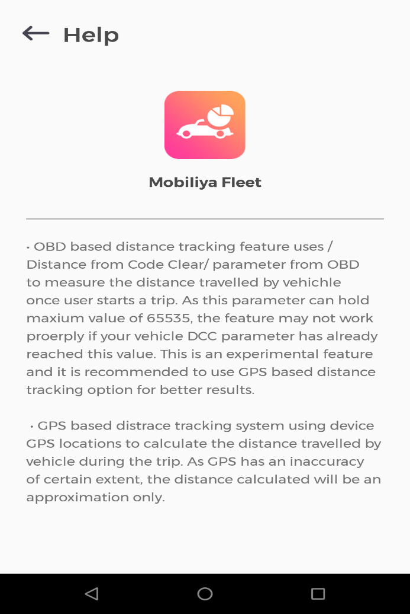

## App Settings Help

Driver can read help page before editing any configuration from app setting page for his information.

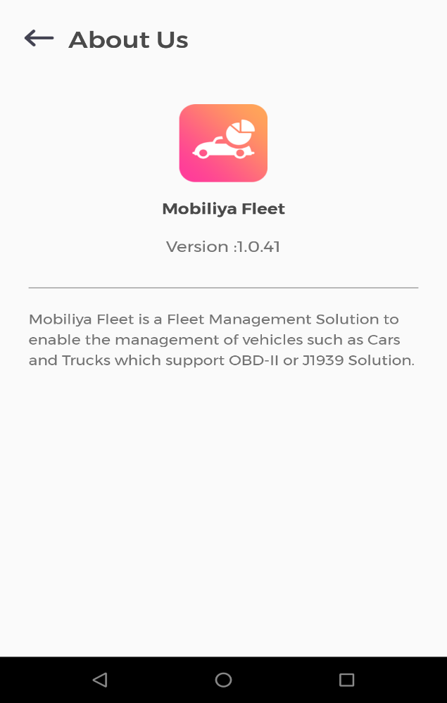

## About Us

About us page gives information of application its uses and latest version.